PWA Video 19 offline fallback pages

<https://www.youtube.com/watch?v=KLQELCvb-B0>

What if user needs to navigate to a page while off line that is not in the cache ? A page that they have not navigated to before?

Show a fall back page so that user has better experience – fall back page to look like the app and say something about not being able to view off line.

Then store the fallback page in the static assets cache , want it to be always available.

Then add it to the service worker

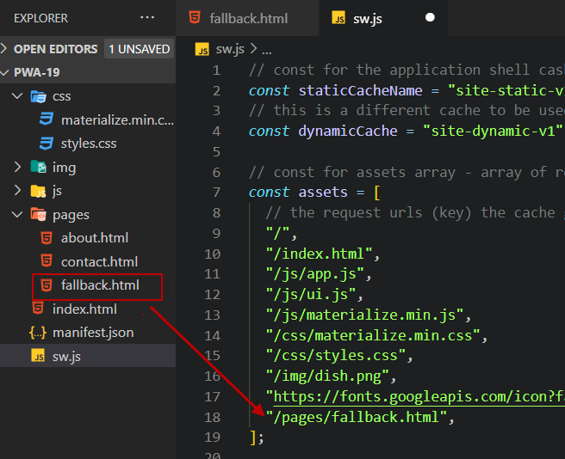

Configure the fetch event so that it serves up the fallback page if the cache doesn’t have the resource.

